University of Gujrat

Department of Software Engineering

LMS Comparisons & ICT Tools
Submitted by:
Muhammad Aliyan
25021598-245
Ghulam Meeran
25021598-191
Abdul Mateen
25021598-259
Mobeen Hashmi
25021598-226
Section:
AB
Course Title:
Applications of Information
and Communication Technology
Course Code:
GESE-203
Submitted to:
Miss Hafsa Shareef
Date Submitted:
12/05/2025
Contents
1. Compare Different LMS and Online Learning Platforms 1
1.1 Comparison of LMS Platforms 1
1.2 Comparison of Online Learning Platforms 2
1.3 Personal Preference in LMS 3
2. Apply ICT Tools & Analyze Virtual Classroom Challenges 4
2.1 Demonstration of ICT Tools 4
2.2 Analysis of Ethical, Social, or Legal Issues 5
2.3 Effective Digital Communication Example 5

1. Compare Different LMS and Online Learning Platforms

1.1 Comparison of LMS Platforms
Selected Platforms:
Moodle and Google Classroom

Criteria | Moodle | Google Classroom
Features | - Highly customizable with thousands of plugins  - Attendance tracking  - Built-in gamification  - SCORM compliance for interactive content. | - deeply integrated with Google Workspace (Docs, Slides)  - simplified interface  - "Stream" for announcements  - plagiarism checker
Benefits | - Gives the institution full ownership of data  - Supports complex course layout suitable for universities  - Open source (free software cost). | - Extremely easy to set up and use  - Requires minimal training for teachers and students  - Seamless mobile app experience.
Type of Deployment | - Self-Hosted: Can be installed on the institution's own servers  - or Cloud: Hosted by a Moodle Partner/Cloud. | Cloud (SaaS): Fully hosted by Google; requires no server maintenance by the school.
Collaboration Options | - Discussion forums  - Wikis (for group editing)  - Glossary contributions  - Peer assessment workshops. | - Class comments on posts  - Private comments on assignments  - Real-time collaboration on Google Docs/Slides.

1.2 Comparison of Online Learning Platforms
Selected Platforms:
Coursera and Udemy
Criteria | Coursera | Udemy
Course Types | - Academic courses  - Specializations  - Full Degrees provided by accredited universities and industry leaders (e.g., Google, IBM). | - Skill-based courses created by individual instructors covering topics from coding and photography to lifestyle and marketing.
Certification Options | - Verified Certificates and Professional Certificates.  - Some credits may count toward university degrees. | - Certificates of Completion  - Primarily for personal knowledge or portfolio building).
Teaching/Learning Model | - Graded assignments  - Semester-like feel with weekly deadlines  - Peer-reviewed projects. | - Self-paced  - No strict schedules or deadlines.  - On-demand video learning
Target Audience | - Students seeking academic credentials  - Professionals seeking career pivots  - University degrees. | - Hobbyists  - Lifelong learners  - Professionals looking for quick, specific skill learning.
Benefits for Learners | - High credibility on CVs  - Access to top-tier university professors  - structured learning path. | - Huge variety of topics  - frequent sales make courses very affordable  - lifetime access to purchased content.

1.3 Personal Preference in LMS
Preferred Platform:
Moodle
Reasoning:
I personally prefer Moodle over Google Classroom. Relating to the features discussed, my preference is based on:
- open-source nature
- Moodle's extensive customization options
- Unlike Google Classroom, which offers a fixed, simplified interface, Moodle allows for a highly tailored learning environment where I can use plugins for gamification, advanced quizzes, and detailed grade books.
- I also like the robust analytics tools in Moodle, which allow both teachers and students to track progress in detail.
- Furthermore, the fact that Moodle can be self-hosted provides a sense of data ownership and security that third-party cloud platforms cannot fully match.

2. Apply ICT Tools & Analyze Virtual Classroom Challenges

2.1 Demonstration of ICT Tools
Selected Tool:
Google Docs
Task:
Creation of a 1-page document on "Benefits of Artificial Intelligence in Education."
Steps followed to create and share this file:
- Accessing the Tool
I opened my web browser, navigated to docs.google.com, and logged in with my Google account.
- Creating the File
I clicked on the "+" icon to create a new document.
- Naming
I clicked on the "Untitled document" field and renamed it "Benefits of AI Education".
- Adding Content
I typed the title in header and entered a list of benefits in body text.
- Formatting
I used the toolbar to bold the Heading to distinguish sections. Then, I selected the list of benefits and clicked the "Numbered List" icon in the toolbar to create a clean, organized list.
- Review
I used the built-in spell checker (Tools > Spelling and grammar) to ensure there were no typos.
- Sharing
I clicked the "Share" button in the top right corner, changed the access setting to "Anyone with the link can view," copied the link, and clicked "Done" to finalize the sharing process.
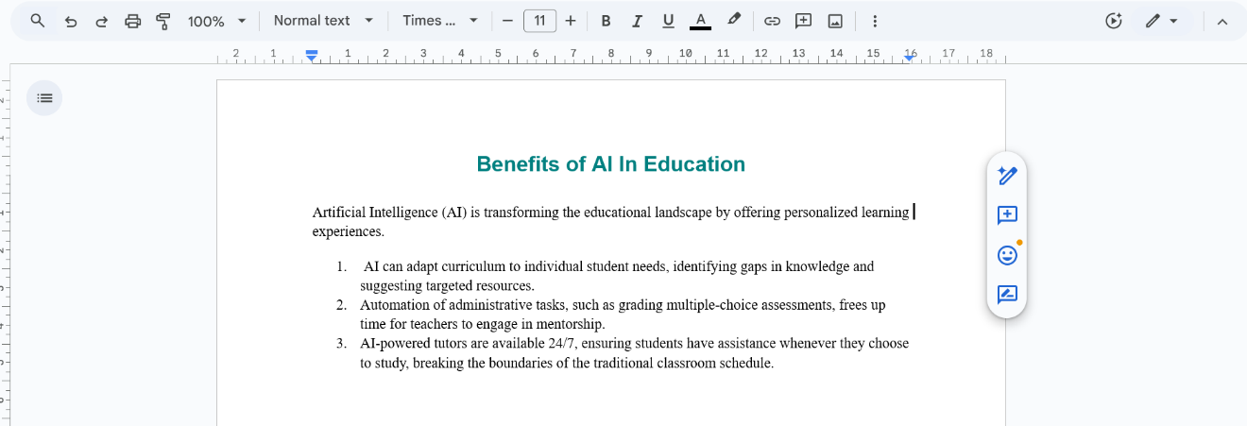

2.2 Analysis of Ethical, Social, or Legal Issues
Social Issue: The Digital Divide in Virtual Classrooms
The digital divide refers to the gap between students who have access to modern information technology (high-speed internet, reliable laptops) and those who do not. In a virtual classroom setting, this creates significant divide in a classroom. Students from lower-income backgrounds may rely on limited mobile data and because our country suffers from poor network coverage it leads to issues like poor video quality, inability to access heavy LMS resources, or frequent disconnections. This inequality affects their academic performance not because of a lack of ability, but due to a lack of infrastructure. Addressing this requires schools to consider alternatives and ensure equal access to hardware before making virtual classrooms mandatory.

2.3 Effective Digital Communication Example
Example: Real-time Collaboration via Google Docs
An effective example of digital collaboration is a group of students working on a research paper using Google Docs. Instead of emailing different versions of a Word file back and forth (which causes version control errors), all students access a single link. They can type simultaneously in different sections, use the "Comment" feature to ask questions about specific paragraphs, and use the "Suggesting" mode to suggest edits without permanently changing the text. This allows for communication and immediate feedback, making the group’s work a lot easier.

